PENCIL uses Zoom video conferencing for our program sessions. Zoom is available for your desktop computer as well as your iPhone, iPad, and Android phones and tablets.

Before your first PENCIL session, we encourage you to download the Zoom.

**Options to Download Zoom**

**Step 1: Install Zoom on Desktop/Laptop/Tablet Device**

1. Click link to the Downloads center: <https://zoom.us/download>

2. Select Download for the kind of device you have for [Mac](https://support.zoom.us/hc/en-us/articles/201362033), [Windows](https://support.zoom.us/hc/en-us/articles/201362033), [Linux](https://support.zoom.us/hc/en-us/articles/204206269), and [ChromeOS](https://support.zoom.us/hc/en-us/articles/213298746" \t "_self), as well as the Zoom Mobile App for [iOS](https://support.zoom.us/hc/en-us/articles/201362993) and [Android](https://support.zoom.us/hc/en-us/articles/200942759).

3. The app will begin downloading on your browser.

**Troubleshooting Tips**

**VPN or VPI Enabled:** Your company may block all downloads while logged into the VPN or VPI, even if you are on your personal device. Be sure to log off your VPN or VPI before logging in.

**Audio Issues:** If you cannot hear others, others cannot hear you while unmuted or you cannot see yourself when video is enabled, ensure external devices (speakers, microphones, cameras) are firmly plugged into your computer. If the problem continues, ensure the proper devices are selected in the participant menu (using arrows next to the “Mute” and “Start Video” options).

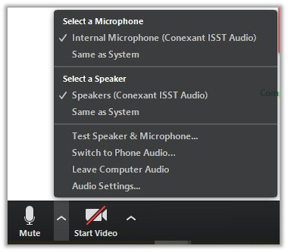 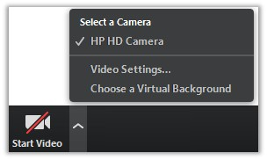

**Apple Products:** If you are using an Apple product, you may have to provide Zoom access to your camera and microphone. To do this choose the Apple menu > System Preferences, click Security & Privacy, then click Privacy. Select Microphone and Camera, selecting the checkbox next to Zoom.

**Zoom Meeting Functions**

**Participant Controls**

Participants have standard controls at the bottom menu bar of the meeting.

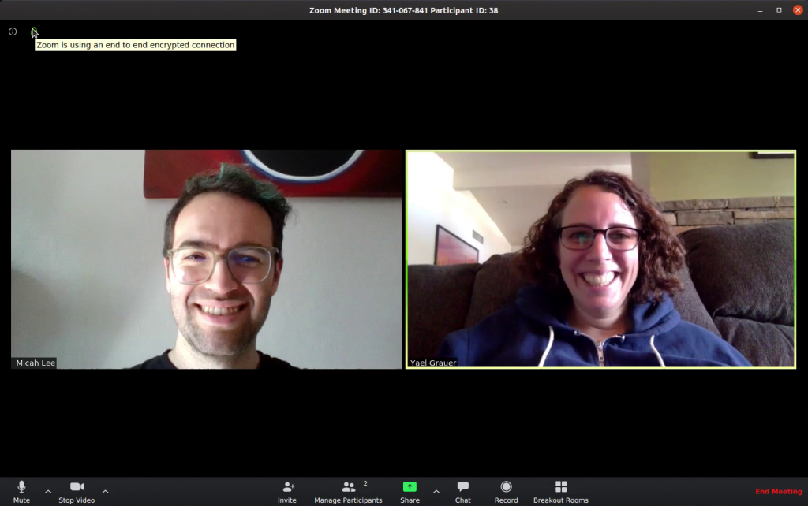

**Polls**

|  |  |  |  |  |  |  |  |  |  |  |
| --- | --- | --- | --- | --- | --- | --- | --- | --- | --- | --- |
| 1 | 2 |  | 3 | 4 | 5 | 6 | 7 | 8 | 9 | 10 |

1. Join Audio/Mute:  If the host gives you permission, you can unmute and talk during the webinar.
2. Start/Stop Video: Turn video on or off. Please be mindful of your surroundings before turning on your video, remember we can see whatever is behind or around you
3. Invite: Ask others to join the meeting (this feature is typically not available in PENCIL webinars)
4. Manage Participants: View other participants and see more options, such as Raise Hand and Rename.
5. Share: Allows participants to share their screen with the full group
6. Chat: Opens webinar chat, allowing you to send chat messages to the host, panelists, and attendees (if permitted)
7. Record: Begin recording the meeting to your local computer (this feature is typically not available in PENCIL webinars)
8. Breakout Rooms: To join or manage a breakout room (a smaller session split off from the main Zoom meeting.)
9. Polls: To control all polls or view current poll
10. Leave Meeting: To exit the meeting

PENCIL facilitators may use Polls and Breakout Rooms to further engage participants in the session.

**Raise Hand**

The raise hand feature in webinar allows attendees, panelists, co-hosts, and the host to raise their hand to indicate that they need something from the host, co-host, or other panelists.

1. Click **Raise Hand**  in the webinar controls.  
   The host will be notified that you've raised your hand.
2. If the host allows you to talk, you may be prompted to unmute yourself. While unmuted, your profile picture and name is displayed to the host and panelists. Only your name is displayed to other attendees.
3. Click **Raise Hand** in the webinar controls to lower it, if needed. This will not mute yourself if you are unmuted.

**Breakout Rooms**

Breakout rooms are sessions that are split off from the main Zoom meeting to allow the participants to meet in smaller groups. PENCIL uses breakout rooms for collaboration and discussion of the meeting.

After the PENCIL Host opens a breakout room, the participants will receive an invitation to join their assigned room. Breakout rooms function and have controls similar to the main session.

If you click **Ask for Help** in the meeting controls, it will notify the meeting host that you need assistance. Confirm that you would like assistance by clicking **Invite Host** and they will be asked to join your breakout room.

The host can move participants between rooms and back to the original main session. When the host ends the breakout rooms, the participants are notified and given the option to return to the main room immediately, or in 60 seconds.

**Polls**

PENCIL facilitators may launch interactive Polls throughout the session where participants are asked to answer the question on the screen.

The Poll will pop up on your device. Please select the answer you want and then press submit.

The PENCIL host will then close the Poll and share the real time results with the group.

